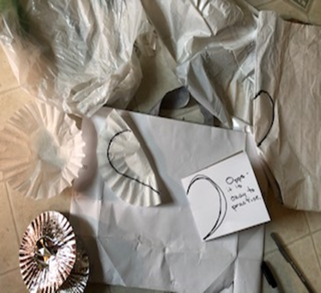 | 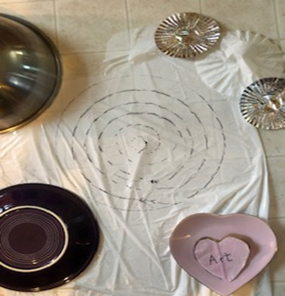 | 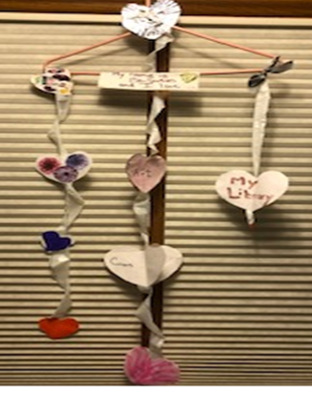  
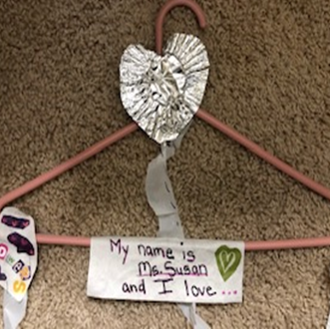 | 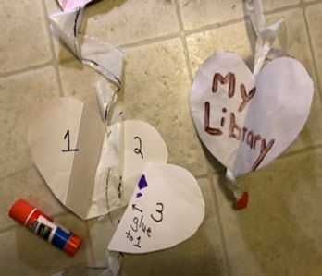
This is Ms. Susan from the Shorewood Public Library. This week I have a special project that comes right from the heart. I know that sometimes, when things change and we are not able to enjoy the things that we love to do, it is easy to forget all of the special things that we do have in our lives. So, we are going to create a unique heart string to hang up or share with others, and have a little fun along the way. It is also a scavenger hunt to find the many items around the house the you could throw away or make into beautiful hearts. I hope you find that making and sharing hearts is a great way to show love and create happy thoughts. Remember, you are missed and loved at the Shorewood Library.

1-Hunt around the house for anything that could be used to make your hearts. It could be paper, plastic bags, frozen food bags (washed), a coffee filter, or even a cardboard box. You just have to use your imagination. Draw your heart shapes and cut them out. Remember, it is okay to practice the rounded part at the top and bring it down to a point. If you fold it in half, both sides of the heart will be even. Or, you can make crazy hearts too! Write down your favorite things on each heart, it could be things you love to eat, people you love, or things you love to do.
2-You can make a spiral string to hang your hearts from, by making a circle and then cutting it evenly smaller to the inside. The bigger the circle, the longer the strip will be. Or you can cut strips from a plastic bag, or use string or yarn. Tie the hanging strings to a hanger or a stick from outside.
3-Make a card that say, My name is ______and I love _____. Fill in the blanks and attach your card to your creation with glue, tape, or a stapler. You can even make 3-D hearts. Cut three hearts the same size, fold one in half and attach it to one half of the second one. Glue one half of the third one to the open half of the first heart, and the other half to the open half on the second heart with the string in the middle. Hang it in your window or outside in a tree when it is not raining.
From my heart to yours - Have fun, be well! Ms. Susan

